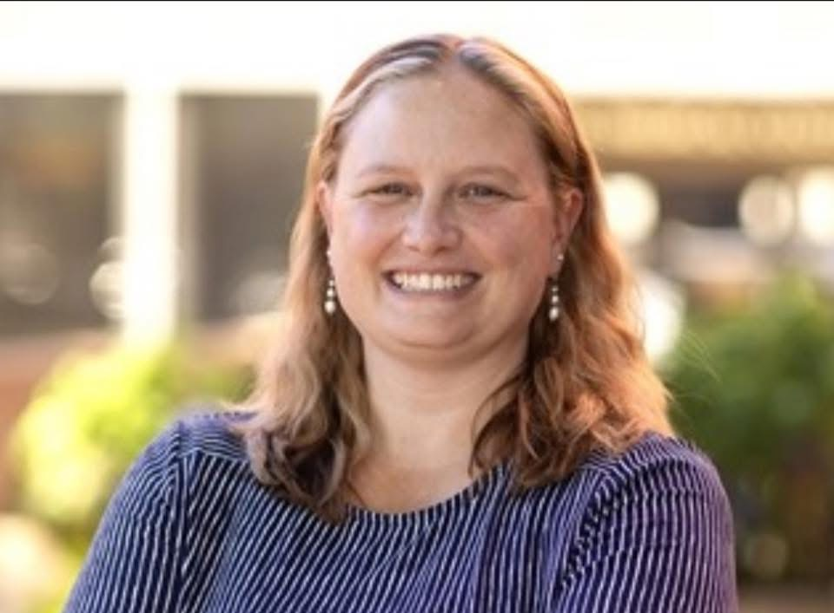
Megan Elizabeth Ingle
4105 Bentwood Cove Dr., Apison, TN 37302
(678) 780-7949 | meganeingle@gmail.com

Professional Summary
Results-driven marketing and project management professional with extensive experience in brand development, event execution, strategic communications, and cross-functional collaboration. Proven track record managing large-scale campaigns, trade shows, promotional initiatives, and budgets across healthcare, education, media, manufacturing, and construction industries. Skilled in relationship management, employee engagement, and integrated marketing strategy.

Core Competencies
- Strategic Event & Trade Show Planning
- Brand Management & Service Line Marketing
- Project Management & Budget Oversight
- Cross-Functional Team Collaboration
- Internal Communications & Engagement
- Social Media & Digital Campaigns
- Press Releases & Public Relations
- Data Analytics & Survey Tools
- Conversational Spanish (Basic)

Technical Skills
SAP, Salesforce, SharePoint, Asana, Excel, PowerPoint, Constant Contact, Zoom, Sprout Social, SurveyMonkey, Eventbrite, Microsoft Teams, etc.

Professional Experience
WDEF News Channel 12 — Chattanooga, TN
Account Sales Executive| November 2025 – Present
- Prospect and develop new business through strategic cold calling and relationship building
- Manage broadcast and digital advertising campaigns for local and regional clients
- Coordinate on-site client visits and commercial production logistics
- Deliver monthly campaign analytics and performance reporting to clients
- Support company-sponsored community and promotional events.

Erlanger Health System — Chattanooga, TN
Marketing & Brand Management | June 2022 – May 2025
- Directed service line branding for internal and external communications
- Managed onboarding materials, promotional apparel, collateral, and signage
- Planned and executed large-scale events, symposiums, and observance campaigns
- Oversaw vendor sponsorships and onsite logistics for conferences
- Implemented multi-platform promotional strategies and internal newsletters
- Led employee engagement initiatives through targeted promotions and activations
Thinking Media / Learning Blade — Chattanooga, TN
Marketing & Project Coordinator | June 2021 – February 2022
- Developed and distributed press releases and marketing emails via Constant Contact
- Managed customer database and state contract communications
- Supported grant and report preparation for state-level clients
- Organized and hosted statewide webinars and professional development events
- Scheduled and coordinated CEO engagements and client training
Hyundai Construction Equipment Americas — Norcross, GA
Assistant Marketing Manager / Event Marketing Specialist | February 2016 – May 2021
- Led national and regional trade show strategy and execution (housing, travel, logistics, staffing)
- Directed advertising, media planning, and public relations efforts
- Managed departmental budgets and aligned spend with forecasted sales goals
- Collaborated with graphic teams for branded promotional content
- Developed dealer engagement events and conducted product training for sales reps
- Maintained merchandising consistency and point-of-purchase materials
Lonza / Arch Chemicals, Inc. — Alpharetta, GA
Marketing Specialist, Consumer Products | June 2008 – September 2015
- Managed event planning and national meeting logistics
- Coordinated dealer incentive programs and processed promotions
- Partnered with vendors for print, digital, and promotional production
- Implemented new ordering and tracking systems, saving up to $40,000 in event budgets
- Streamlined Salesforce processes, reducing marketing allowance administration by 40%

Kenneth G. Way (KGW) — Chattanooga, TN
Marketing Assistant | May – September 2007
- Assisted in planning major client events and created supporting materials
- Developed collateral and coordinated email campaigns
Komatsu — Signal Mountain, TN
Customer Service Representative | May – August 2006
- Handled distributor relations during component shortages
- Created crisis-response communications for key customers
- Managed order processes using SAP systems

Education
Berry College — Mount Berry, GA
Bachelor of Science in Marketing
- Graduated in 3.5 years
- President, Berry Association of Marketers
- Presented research at national marketing conference (Atmospherics in Retail, San Diego, CA)
Chattahoochee High School — Alpharetta, GA
- AP Math, Joint Enrollment English
- Varsity letters in Basketball, Softball, and Golf

Community Involvement
- STARS Volunteer Rescue Team
- Assist local commissioner Jeff Eversole with local EMS events
- Habitat for Humanity
- Stephen Ministry
- Great Day of Service
- Interests: Singing, Camping, Golf
References available upon request

